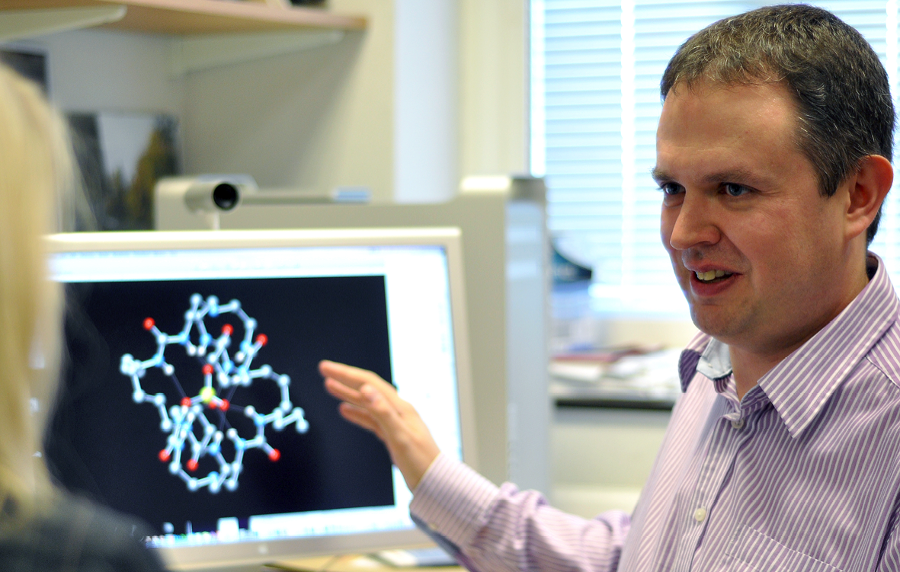**NEW ANION RECEPTORS AND TRANSPORTERS**

*Philip A. Gale*

Chemistry, University of Southampton, Southampton SO17 1BJ, United Kingdom. [philip.gale@soton.ac.uk](mailto:philip.gale@soton.ac.uk)

Diseases or “channelopathies”, such as cystic fibrosis, are caused by mis-regulation of anion transport across epithelial cell membranes. A number of research groups including our own are developing synthetic compounds to mediate anion and hence replace the functionality of the faulty anion channels. Additionally disruption of chemical potentials within cells can lead to apoptosis hence such compounds may have anti-cancer activity.

By studying structurally simple systems and varying their properties to change the degree of preorganisation, affinity for anions or lipophilicity we have begun to rationalize why particular anion transport mechanisms (co-transport or antiport processes) occur in particular cases. For example we have studied the chloride transport properties of isophthalamide and pyridine-2,6-dicarboxamide based receptors with pendant methylimidazole groups that were designed to co-transport H+ and Cl- We observed that more pre-organised pyridine-based receptor was the more efficient transporter – a finding replicated with a series of isophthalamides in which one contained hydroxyl groups designed to preorganise the receptor. This latter class of compound, together with the natural product prodigiosin can transport bicarbonate (as part of a chloride/bicarbonate antiport process) across lipid bilayer membranes.

Recently we have studied the transport properties of simple thioureas and squaramides and shown that these compounds are highly potent chloride/bicarbonate antiport agents that function at low concentrations whilst urea analogues are inactive. The higher log Ps of the thiourea compounds as compared to their urea analogues may provide a clue to the high potency of these. In a series of fluorinated compounds containing ureas and thioureas we have shown that a higher degrees of fluorination results in more effective transporters (due to higher lipophilicity) and in human cancer cell lines that the most effective transporters possess the highest anti-cancer activity (presumably due to co-transport of HCl or antiport of chloride and bicarbonate depolarizing acidic compartments within cells so triggering apoptosis).

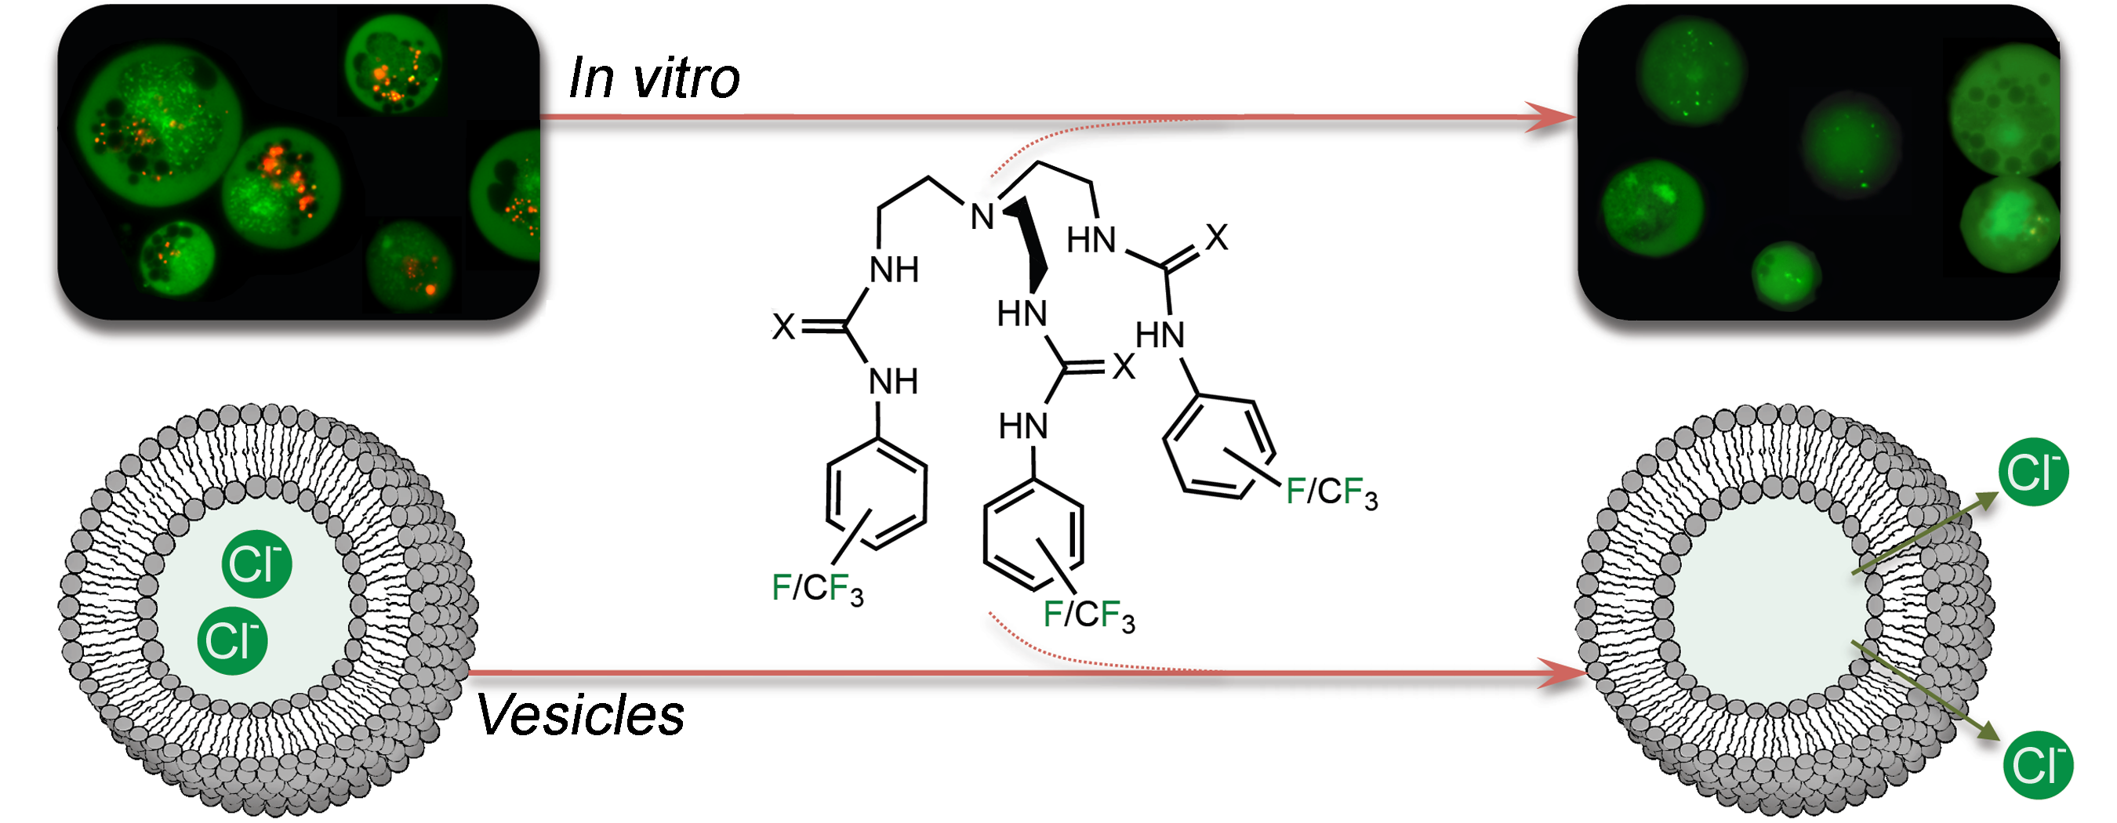

*Recent publications:*

N. Busschaert and P.A. Gale, *Angew. Chem. Int. Ed.* DOI: 10.1002/anie.201207535; S.J. Moore, C.J.E. Haynes, J. González,J.L. Sutton, S.J. Brooks, M.E. Light, J. Herniman, G. J. Langley, Vanessa Soto-Cerrato, R. Pérez-Tomás, I. Marques, P.J. Costa, V. Félix and P.A. Gale, *Chem. Sci.* 2013, 4, 103-117; N. Busschaert, I.L. Kirby, S. Young, S.J. Coles, P.N. Horton, M.E. Light and P.A. Gale, *Angew. Chem. Int. Ed.* 2012, 51, 4426-4430; P.A. Gale, *Acc. Chem. Res.* 2011, 44, 216-226; N. Busschaert, M. Wenzel, M.E. Light, P. Iglesias-Hernández, R. Pérez-Tomás and P.A. Gale, *J. Am. Chem. Soc.,* 2011, 133, 14136-14148; M. Wenzel, M.E. Light, A.P. Davis and P.A. Gale, *Chem. Commun.* 2011, 47, 7641-7643; S.J. Moore, M.G. Fisher, M. Yano, C.C. Tong and P.A. Gale, *Chem. Commun.* 2011, 47, 689-691; N.J. Andrews, C.J.E. Haynes, M.E. Light, S.J. Moore, C.C. Tong, J.T. Davis, W.A. Harrell Jr. and P.A. Gale, *Chem. Sci.,* 2011, 2, 256-260; C.J.E. Haynes and P.A. Gale, *Chem. Commun.* (invited Highlight article), 2011, 47, 8203-8209; P.A. Gale, C.C. Tong, C.J.E. Haynes, O. Adeosun., D.E. Gross, E. Karnas, E. Sedenberg, R. Quesada, and J.L. Sessler, *J. Am. Chem. Soc.* 2010, 132, 3240-3241; J.T. Davis, P.A. Gale, O.A. Okunola, P. Prados, J.C. Iglesias-Sanchez, T. Torroba and R. Quesada, *Nature Chem.* 2009, 1, 138-144.